Power BI – Module End Evaluation

Q1: Data Cleaning and Loading (5 Marks)
You are provided with a dataset named SalesData_1000Rows_WithIssues.csv which contains customer order information. The dataset has missing values, duplicate entries, and inconsistent date formats.
Tasks: a) Import the dataset into Power BI using Power Query Editor.
ANS:
Imported SalesData_1000Rows_WithIssues.csv into Power BI using Power Query Editor.
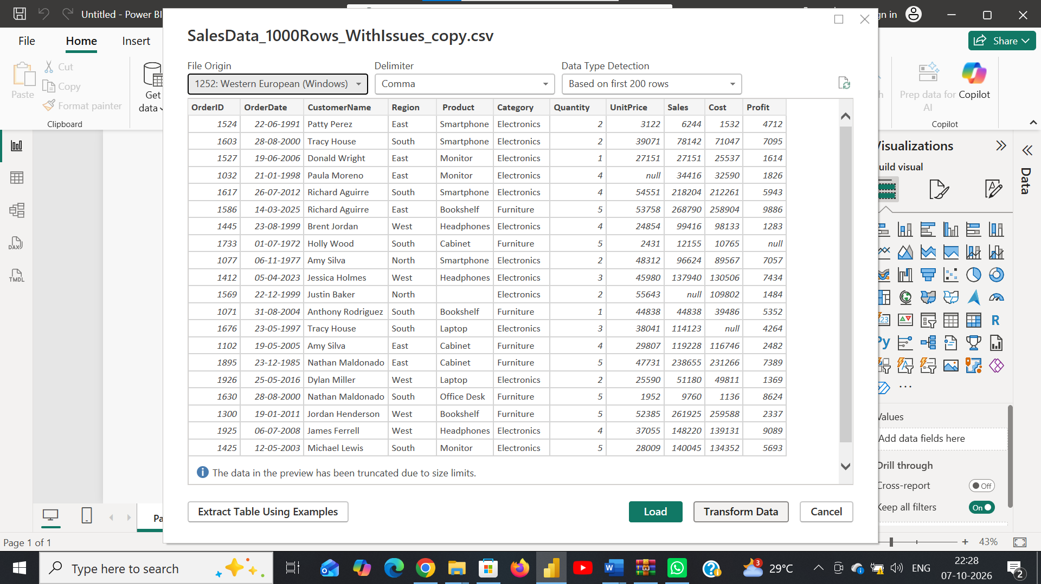
b) Perform the necessary data cleaning steps to prepare it for analysis, including:
i) Handling missing values in columns.
ii) Removing duplicate rows.
iii) Standardizing the OrderDate column to a consistent date format.
ANS:
Cleaned the dataset by:
* Handling missing values.
* Removing duplicate rows.
* Converting OrderDate to a consistent Date format.
* Checking and correcting column data types.
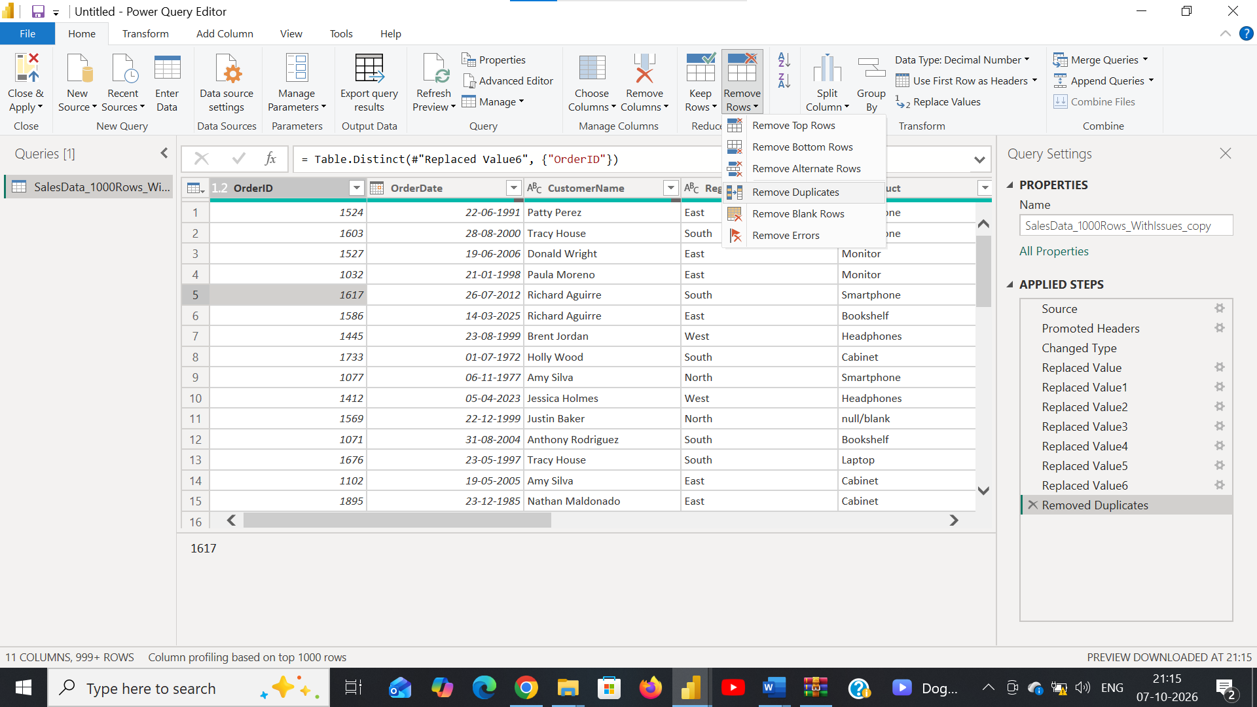
c) Load the cleaned dataset into the Power BI model.
ANS: Clicked Close & Apply to load the cleaned dataset into the Power BI model.
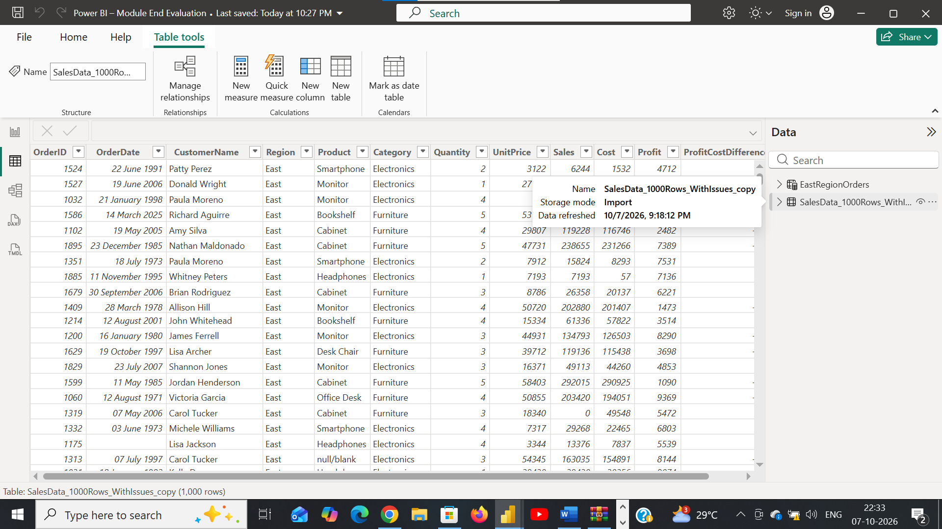

Q2: Visualizations and Insights (5 Marks)
Using the cleaned dataset, create meaningful visual representations to analyze order and profit trends.
Tasks: a) Create a Pie Chart showing order distribution across different regions.
b) Create a Column Chart to display the top 5 trending products based on the number of times each product was ordered.
c) Create a Line Chart to show the profit trend over time.
Ans:
Created All 3 Charts:
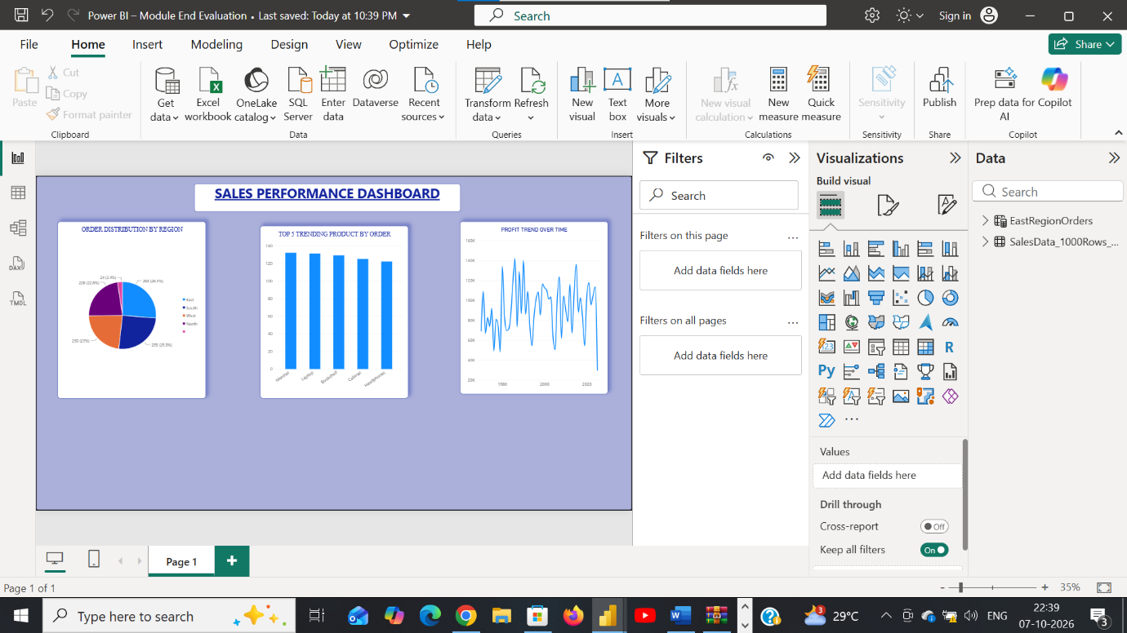

Q3: DAX Calculations (5 Marks)
Apply DAX to create calculated elements and gain deeper insights.
Tasks: a) Create a Calculated Table named EastRegionOrders that filters and displays only the orders from the East region.
Ans:
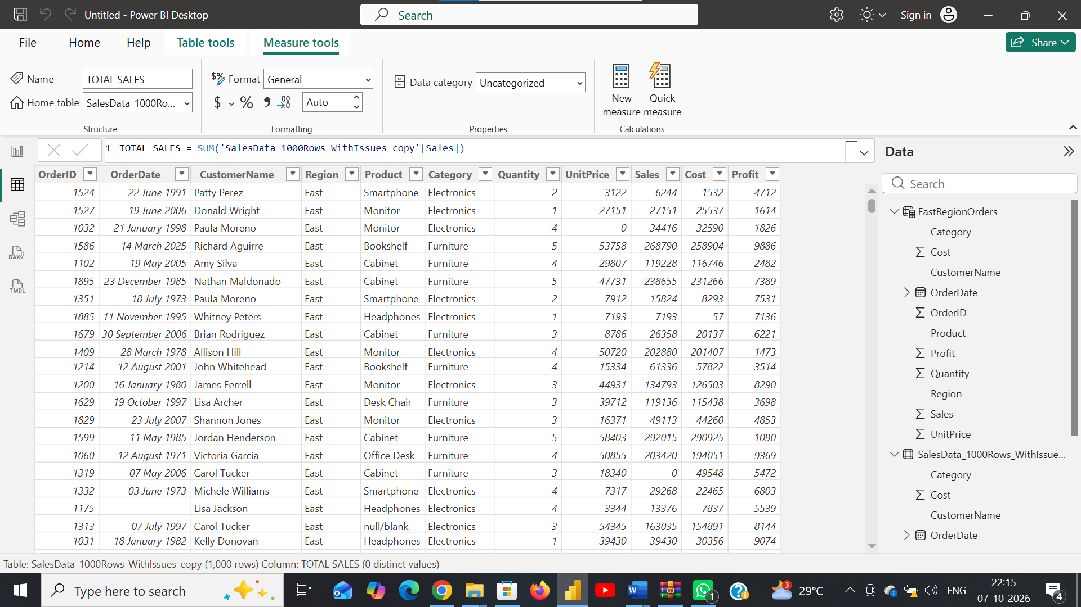
b) Create a Calculated Column to compute the difference between the Profit and Cost columns. Name it ProfitCostDifference.
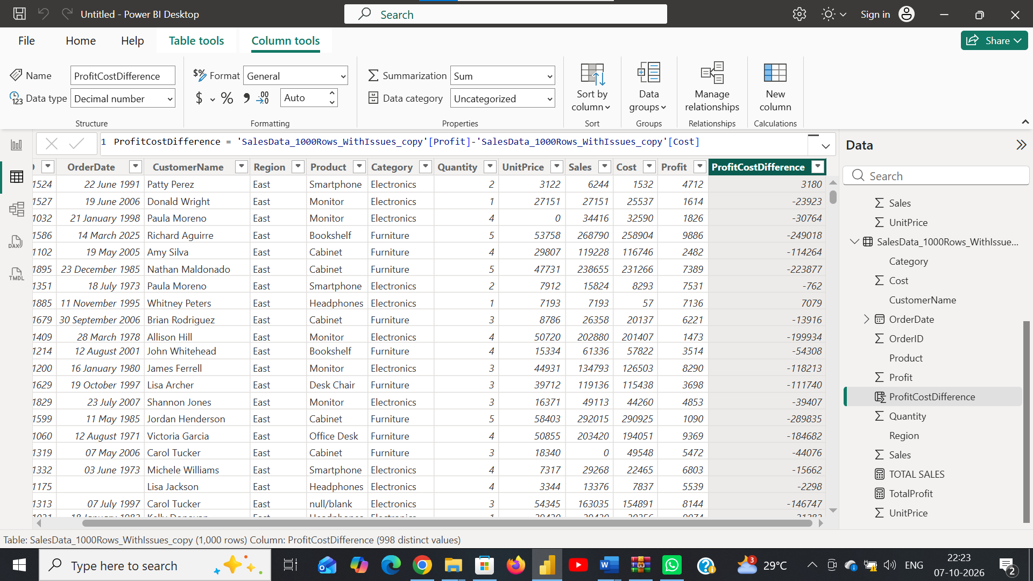
c) Create a Calculated Measure to find the total profit earned. Name it TotalProfit.
Ans:
